Abstract

This graduation project aims to optimize the management of student data, enhance accessibility, and alleviate the administrative burden on staff members. It involves re-implementing the previous year's graduation project, 'FCAI website (student’s section),' with a focus on enhancing its performance and effectiveness. Through the utilization of innovative solutions, we aspire to contribute to the enhancement of the institution’s operational efficiency and overall user experience by refining design and functionality to better align with the needs of the student affairs department.
Table of Contents
Chapter 1 Introduction 4
1.1 Background and Motivation 4
1.2 Problem Statement 4
1.3 Objectives 4
1.4 Project Scope and Limitations 5
1.5 Project Plan (Gantt Chart) 6
1.6 Project Methodology: Agile 6
1.7 Project Report Outline 7
Chapter 2 Market and Literature Survey 8
2.1 SWOT analysis 8
Chapter 3 Student Affairs Analysis 10
3.1 Functional Requirements 10
3.2 Non-Functional Requirements 10
3.3 Stakeholders: 11
3.4 Use Case Diagram 12
3.5 Use Case Description 15
3.5.1 Register Course (Ecom 2023) 15
3.5.2 Push Notification (Ecom 2023) 16
3.5.3 View Profile (Ecom 2023) 17
3.5.4 Register Graduation Project (Ecom 2023) 18
3.5.5 Evaluate Course (Student’s Side) (Ecom 2023) 19
3.5.6 Chat (Ecom 2023) 20
3.5.7 View Office Hours and Locations (Ecom 2023) 21
3.5.8 View Announcements (Ecom 2023) 22
3.5.9 Report Statistics (About student Results) (Ecom 2023) 23
3.5.10 View Top 50 (Ecom 2023) 24
3.5.11 View Student’s Data (Ecom 2023) 25
3.5.12 View a schedule of All Courses and All Levels to the professor and TAs (Ecom 2023) 26
3.5.13 View Course Evaluation (Ecom 2023) 27
3.5.14 Download Schedule or Bylaw (Ecom 2023) 28
3.5.15 Search (Ecom 2023) 29
3.5.16 Add Course/Group Preferences (Ecom 2023) 30
3.5.17 Login User (Ecom 2023) 31
3.5.18 Add Student (Ecom 2023) 32
3.5.19 Add Announcement (Ecom 2023) 33
3.5.20 Add Schedule File (Ecom 2023) 34
3.5.21 Accept New Students 35
3.5.22 Issue Letter for various purposes. 36
3.5.23 Issue Reports & statistics. 37
3.5.24 Handle Student Request 38
3.6 ERD 39
3.7 Component Diagram 40
3.8 Sequence Diagram 41
3.8.1 Register Course (Ecom 2023) 41
3.8.2 Internal Chat (Ecom 2023) 42
3.8.3 View Office Hours (Ecom 2023) 43
3.8.4 View Schedule (Ecom 2023) 44
3.8.5 Student Registration 45
3.9 BPMN 46
3.9.1 Student Registration 46
3.9.2 Stop Credential 47
3.9.3 Withdrawal/Incomplete 48
3.9.4 Clearing 49
Chapter 4 Design & Implementation 50
4.1 Technologies and Tools 50
4.2 System Screens 51

List of Figures
Figure 1. Gantt Chart 5
Figure 2. Use Case Diagram for Professor and TA (Ecom 2023) 11
Figure 3. Use Case Diagram for Student and Admin (Ecom 2023) 12
Figure 4. Student Affairs Use Case Diagram 13
Figure 5. Component Diagram 38
Figure 6. ERD 39
Figure 7. Register Course Sequence Diagram (Ecom 2023) 40
Figure 8. Internal Chat (Ecom 2023) 41
Figure 9. View Office Hours sequence Diagram (Ecom 2023) 42
Figure 10. View Schedule Sequence Diagram (Ecom 2023) 43
Figure 11. Student Registration Sequence Diagram 44
Figure 12. Student Accept 45
Figure 13. Stop Credential 46
Figure 14. Withdrawal/Incomplete 47
Figure 15. Clearing 48
Figure 16. Authentication screen 50
Figure 17. Home page 51
Figure 18. Students 52
Figure 19. Register New Students. 53
Figure 20. Choose Excel File 54
Figure 21. Upload Excel File 55
Figure 22. Mapping-1 56
Figure 23. Mapping-2 57
Figure 24. Loading Screen 58
Figure 25. Confirmation 59

Introduction
The primary objective of this project is to develop an internal system for the student affairs department that reduces the staff’s workload and automates certain tasks, thereby simplifying, and expediting their job responsibilities in an efficient manner. Additionally, we plan to integrate our system with another existing system (new E-com graduation project developed in 2023). However, after careful assessment, which included testing the existing system, we have found that integrating with it would require a significant amount of time and may not be feasible within a given deadline. Therefore, we have decided to develop this system from scratch to address its deficiencies effectively.

Background and Motivation
The student affairs staff faces a heavy manual workload in managing students and departmental operations, posing challenges in terms of time, resources, and potential errors. These tasks need to be automated to ease their workload, minimize errors, and enhance departmental efficiency.

Problem Statement
Current manual processes within the student affairs department create barriers to efficiency and effectiveness. These manual processes hinder productivity and increase the likelihood of errors. The department’s ability to provide optimal support and services to students is compromised.

Objectives
- Develop and integrate automation features within the student affairs internal system to reduce manual workload.
- Enhance system security and compliance with data protection regulations.

Project Scope and Limitations
Scope:

- Automation Features: The project will focus on developing and integrating automation features into the student affairs internal system. These features will target specific tasks and processes that are currently performed manually, with the aim of reducing the workload of the staff.

- Enhanced Security: Alongside automation, the project will also enhance the security of the system. This includes implementing measures to protect sensitive student data and ensuring compliance with relevant data protection regulations.
- Improved Analytical Reporting: The project will streamline and optimize the process of generating analytical reports. Currently, creating reports is a laborious and time-consuming task. The project will introduce features and tools to make the generation of reports more efficient, enabling faster and more effective data analysis for better decision-making.

Limitations:

- Resource Limitations: The project will be subject to resource constraints, including budget, time, and available technology. The extent of automation and security enhancements will depend on the resources allocated.

- Integration Challenges: Integration of automation features may face challenges related to compatibility with existing systems and software. These challenges could impact the timeline and effectiveness of the project.

- Training and Adoption: The success of the project relies on staff adoption of the automated system. However, training and change management may pose limitations in terms of staff acceptance and adaptation to the new system.

- Data Migration: Transferring existing data from manual records to the automated system may be a complex task. Data migration challenges could affect the accuracy and completeness of the digital records.

- Scope Creep: To maintain project focus and efficiency, it's important to define clear boundaries for the scope. Scope creep, which involves the unplanned expansion of project goals, will be managed and minimized.

- User Feedback and Iteration: While the project aims to address current needs, evolving user requirements may arise during its development. The ability to accommodate changes and feedback within the defined scope will be considered.

- Testing and Quality Assurance: Thorough testing is crucial to ensure that the automated system operates reliably and accurately. Limitations in testing resources or unforeseen technical issues could impact the project's timeline.

The project will strive to address these limitations while staying within the defined scope to achieve its objectives of reducing manual workload, enhancing system security, and improving efficiency within the student affairs department.

Project Plan (Gantt Chart)

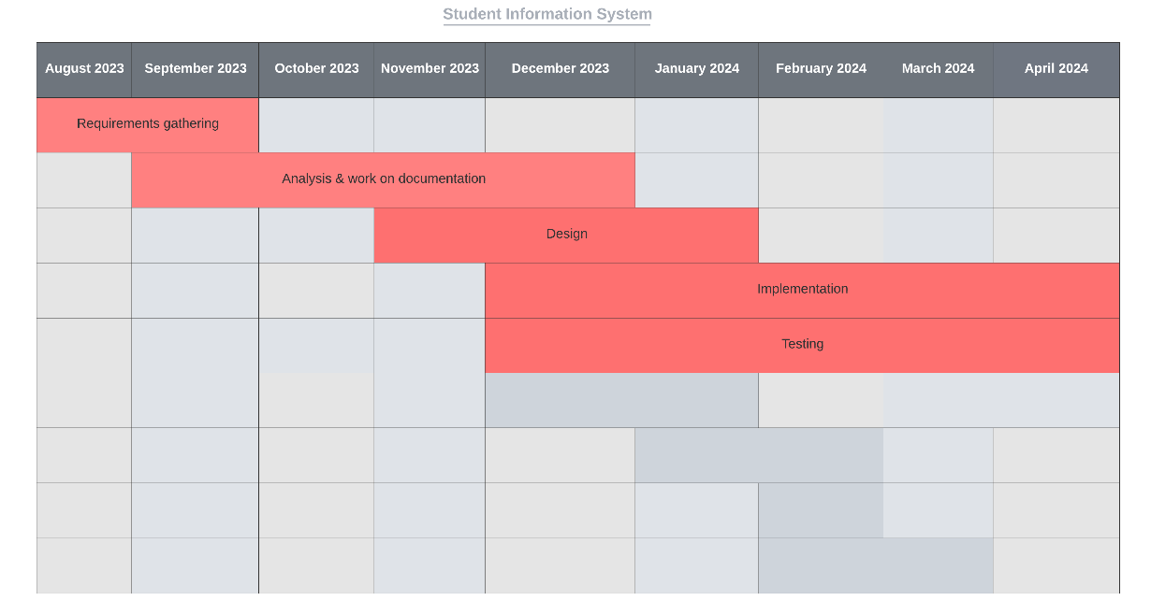
Figure 1. Gantt Chart

Project Methodology: Agile
We will choose the Agile methodology as the preferred approach to manage the project aimed at improving the student affairs internal system. This choice is driven by the following reasons:
- Flexibility and Adaptability: The nature of this project involves continuous improvement and evolving requirements.
- Stakeholder Collaboration: Encourages close collaboration with stakeholders, including student affairs staff and system users. This collaboration ensures that their input is actively considered throughout the project, resulting in a system that better aligns with their needs.
- User-Centric Focus: Place a strong emphasis on delivering value to end-users promptly. This aligns perfectly with the goal of improving the student affairs internal system to enhance user experience and efficiency.
- Early and Frequent Deliveries: Promotes the delivery of small, functional increments at regular intervals. This approach allows us to provide tangible results quickly, keeping stakeholders engaged and informed about project progress.

By choosing agile as our project methodology, we are not only embracing its inherent flexibility and stakeholder collaboration but also leveraging its capacity for internal iterative cycles. This approach will enable us to adapt to changing requirements, prioritize user needs, and refine our deliverables.

Project Report Outline
This document outline will be as follows:
- Chapter 2 presents the literature review of the project.
- Chapter 3 presents the analysis of the Student Affairs.
- Chapter 4 presents an explanation of the implementation and design of the project.
- Chapter 5 presents test cases and project evaluation.
- Chapter 6 concludes the work and lessons learned, then sheds light to future work.

Market and Literature Survey

SWOT analysis
Strengths:
- Improved Efficiency: The system streamlines manual processes, reducing the workload and increasing the efficiency of student affairs staff.
- User-Focused: Enhancing the experience for both staff and students.
- Flexibility: Agile methodology allows for adaptability to changing requirements, ensuring the system remains up to date.
- Collaboration: Stakeholder collaboration is encouraged, leading to a system that aligns well with the needs of the department.

Weaknesses:
- Implementation Challenges: Transitioning to an automated system may pose challenges, including staff training and potential resistance to change.
- Resource Intensive: Developing and implementing the system may require significant resources, both in terms of time and finance.
- Data Migration: Migrating existing data to the new system may be complex and time-consuming, potentially causing data integrity issues.
- Integration Complexity: Integrating the system with other existing systems or databases may present technical challenges.

Opportunities:
- Continuous Improvement: Agile methodology allows for ongoing refinement and adaptation, ensuring the system evolves to meet changing needs.
- Data-Driven Decision-Making: The system's enhanced analytics capabilities offer opportunities to make data-driven decisions and improve services.
- Increased User Adoption: As the system becomes more user-friendly and efficient, it can lead to higher user adoption rates.
- Expanded Services: The system can be expanded to include new services or features to meet emerging needs.

Threads:
- Technical Challenges: Technical issues or system failures could disrupt operations and negatively impact user satisfaction.
- Data Security: The system must address potential security vulnerabilities to protect sensitive student data.
- User Resistance: Resistance to change from staff or students could impede the successful implementation and adoption of the system

Student Affairs Analysis

Functional Requirements
- Automate student registration.
- Integrate CKES with new E-com.
- Reporting and analytics

Non-Functional Requirements

Performance Requirements:
- The system should be able to handle concurrent user sessions without significant degradation in response times, with a response time of less than 2 seconds for common operations.
Usability Requirements:
- The system should have an intuitive and user-friendly interface to ensure that both technical and non-technical staff can easily navigate and use the system without extensive training.
Security Requirements:
- The system must implement strong user authentication and authorization mechanisms to protect sensitive student data.
Availability Requirements:
- The system should be available 24/7, with a maximum allowable downtime of no more than 1 hour per month, scheduled during off-peak hours.
Adaptability Requirements:
- The system should be able to accommodate changes in student affairs processes and policies without requiring extensive code changes and support configuration changes through an admin interface.
Reliability Requirements:
- It should have automated backups and disaster recovery procedures in place.
Compatibility Requirements:
- The system should be compatible with commonly used databases and operating systems.

Stakeholders:
- Student affairs Department/Administrators: Oversee the website's development, maintenance, and content management. Ensure that the website aligns with the department's goals and objectives. Approve and update content as needed.
- Vice Dean: Approval of Student Requests / Accessing Reports and Data / Ensuring that approval decisions align with institutional policies, academic standards, and departmental guidelines.

- Center of knowledge & Electronic Services (CKES)

- Students

Use Case Diagram
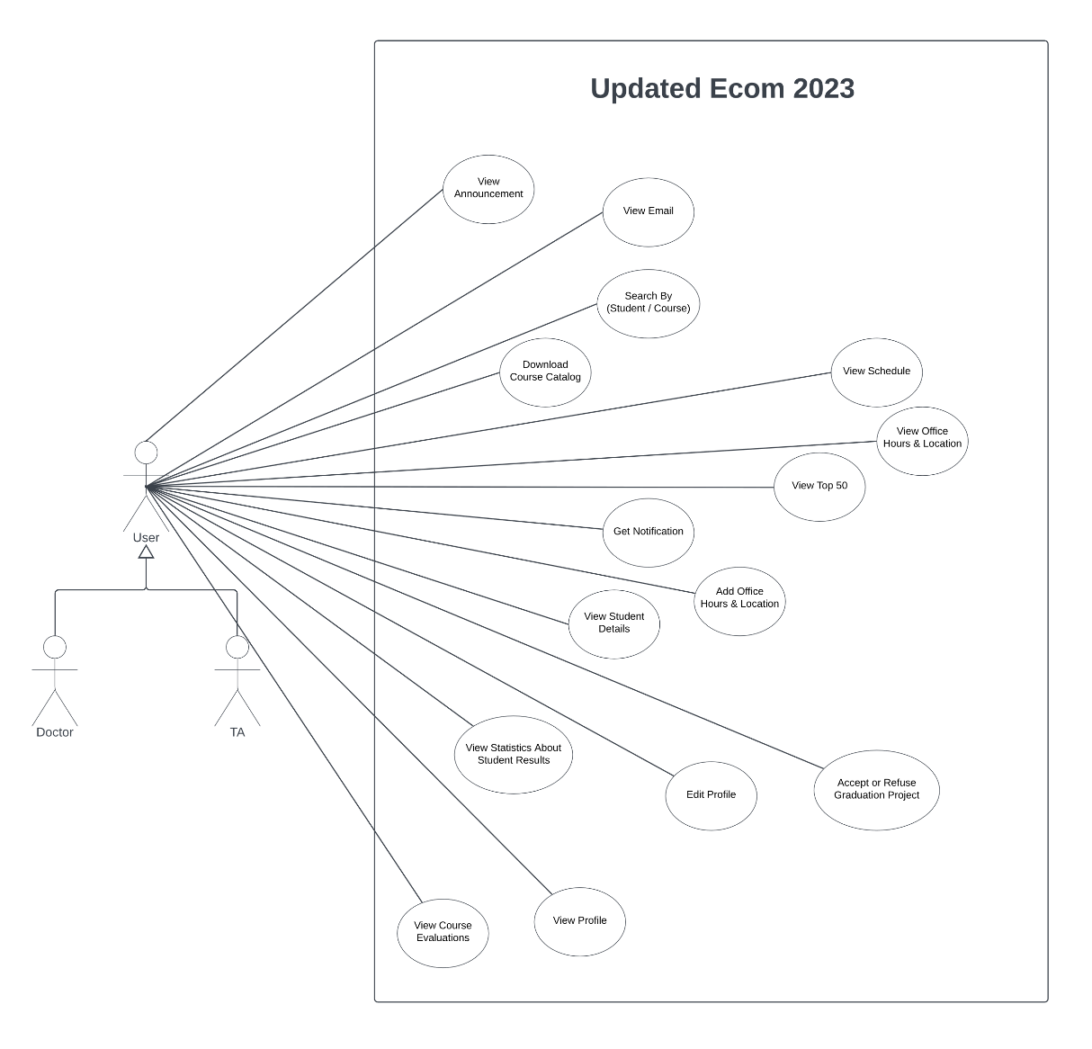
Figure 2. Use Case Diagram for Professor and TA (Ecom 2023)

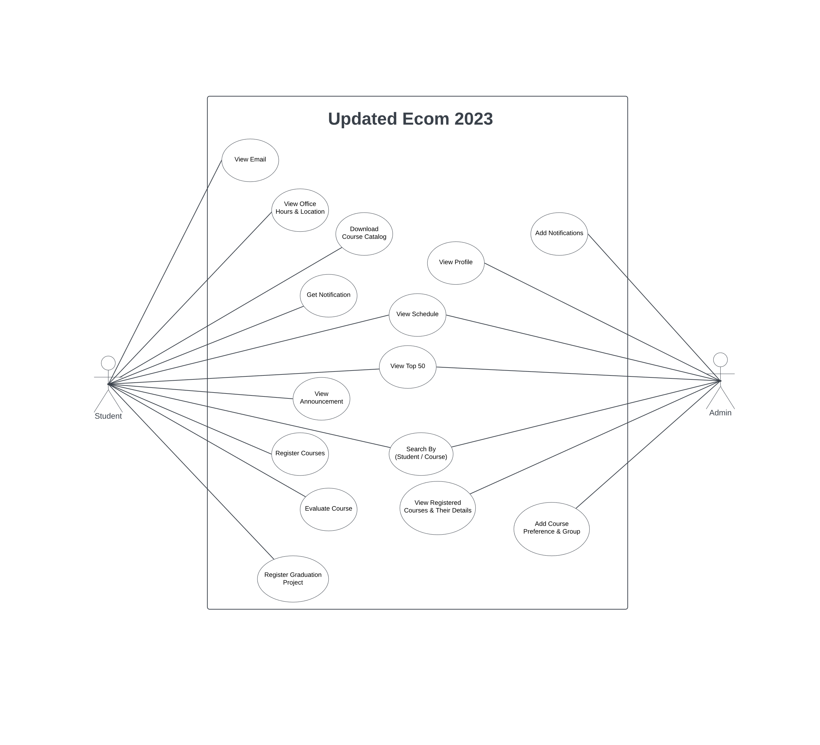
Figure 3. Use Case Diagram for Student and Admin (Ecom 2023)

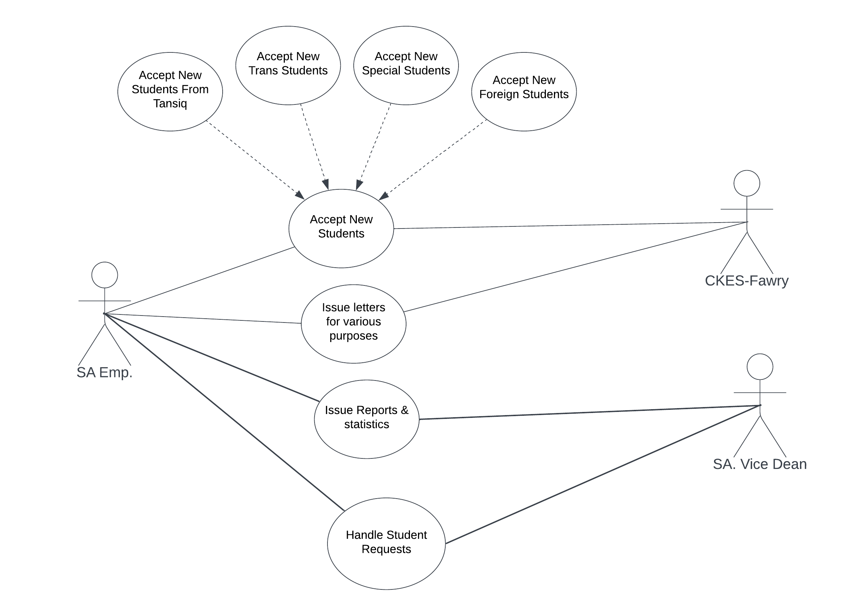

Figure 4. Student Affairs Use Case Diagram

Use Case Description

Register Course (Ecom 2023)
Use case name | Register Course
Scenario | When the student receives a notification that the registration is opened the student enters to select his courses and their groups.
Triggering event | When the registration opens.
Brief description | When the student receives a notification that the registration is opened the student enters and shows a list of available courses and then selects his courses and their groups.
Actors | Student
Related use cases | Login User
Stakeholders | Student, Student Affairs, Professor
Preconditions | Students must have an existing account.
Postconditions | Both the related courses and their groups are updated.
 | Actor | System
Flow of activities | 1. The student opens his/her registration page.  2. The student selects his/her courses.  3. The student selects his/her groups. | 1.1. System displays all available courses for this student.  2.1. System checks the limit of credit hours of this user.  3.1. System assigns to a group.  3.2. System returns the schedule.
Exception conditions | 2.1 Students reach the minimum or maximum credit hours’ limit.  3.1 There are conflict between the groups or courses.

Push Notification (Ecom 2023)
Use case name | Push Notification
Scenario | When the Professor or Student Affairs opens the registration, publishes results of exams, schedule is released or there is an announcement.
Triggering event | When there is new news about results, schedule, or registration.
Brief description | When the registration opens, there is an announcement or the schedule is released, A notification will be sent to students and also will be sent to the professor and TA if the results of feedback of the students are ready or there is an announcement, or the schedule is released.
Actors | Student Affairs
Related use cases | Login User
Stakeholders | Professor, Student Affairs.
Preconditions | Student Affairs must upload the schedule, results or open the registration.
Postconditions | Students, Professors, or TAs go to the site and follow the notification.
 | Actor | System
Flow of activities | 1. The Student Affairs upload the schedule, results or open the registration.  2. The TA, Professor, and student received the notification. | 1.1. System push notification to TA, Professor, and student.
Exception conditions | 1.1. Student, professor, or TA doesn't activate the  notification feature.

View Profile (Ecom 2023)
Use case name | View Profile
Scenario | User could see his/her profile.
Triggering event | When the user wants to check his/her information and edit it if he/she wants.
Brief description | When the registration opens or the schedule is released, there is an announcement. A notification will be sent to students as well as the professor and TA if the results of feedback of the students are ready or there is an announcement, or the schedule is released.
Actors | Student, professor, and TA
Related use cases | Login User
Stakeholders | Student, professor, TA, and student affairs.
Preconditions | User must have an existing account
Postconditions | ---
Flow of activities | Actor | system
 | 1. User open his /her profile | 1.1 System display User information
Exception conditions | ---

Register Graduation Project (Ecom 2023)
Use case name | Register Graduation Project
Scenario | When the registration of the graduation project opens, the student can register the graduation project and put the idea of it, then select from available professors and TAs from his/her department.
Triggering event | When the registration of the graduation project opens.
Brief description | When the student receives a notification that the registration is opened the student enters the project idea then selects from available professors and TAs from his/her department.
Actors | Student, Professor, and TA
Related use cases | Login User and Get Notification.
Stakeholders | Student, professor, TA, and student affairs.
Preconditions | Students must have an existing account.
Postconditions | The student will get a reply from the professor or TA.
Flow of activities | Actor | System
 | 1. The student sends a description about the graduation project to the professor.  2.Professor accepts that team.  3. The student could view the acceptance. | 1.1. System sends it to the Professor.  2.1. System sends the acceptance to the team.
Exception conditions | 2. Professor refuses that team.

Evaluate Course (Student’s Side) (Ecom 2023)
Use case name | Evaluate Course (Student’s Side)
Scenario | When the student receives an announcement about the course feedback that he/she can choose each course and puts his/her feedback.
Triggering event | When the Feedback of content of courses, professors and TAs is opened.
Brief description | When the student receives an announcement about the course feedback that he/she can choose each course and put his/her feedback about the professor, content, and the TA.
Actors | Students
Related use cases | Login User, Get Notification (for making the feedback).
Stakeholders | Student, professor, and TA.
Preconditions | Students must have an existing account and register for that course.
Postconditions | Feedback sent to Professors, TAs.
Flow of activities | Actor | System
 | 1. The student receives notification that he/she could write his/her feedback about courses.  2. Students enter to give his/her feedback about the content of the courses, professors, and TAs.  3.Professor and TA receives the feedback. | 2.1. System sends the feedback to the professor and TA without the student's information.
Exception conditions | 2.2 Student is not registered in this course.

Chat (Ecom 2023)
Use case name | Chat
Scenario | The student can chat with his/her professor and TA.
Triggering event | When the student wants to connect with his/her professor or TA.
Brief description | The student can chat with his/her professor and TA to ask about the content he/she doesn’t understand or any other question.
Actors | Student, professor, and TA.
Related use cases | Login User.
Stakeholders | Student, professor, and TA.
Preconditions | Students must have an existing account.
Postconditions | Students understand missing things for them.
Flow of activities | Student | Professor or TA
 | 1. The student can start chatting with his/her professor or TA. | 1.1 The professor or TA receives the message and answers it when he/she is available.
Exception conditions | 2. Students are not logged in the system.

View Office Hours and Locations (Ecom 2023)
Use case name | View Office Hours and Location
Scenario | The student can view the office hours of professors and TAs can also view the location of their offices.
Triggering event | ---
Brief description | The student can view the office hours of professors and TAs can also view the location of their offices.
Actors | Student, professor, and TA.
Related use cases | Login User.
Stakeholders | Student Affairs, professor, and TA.
Preconditions | Students must have an existing account.
Postconditions | A report of office hours of professors and TAs with their location.
Flow of activities | Actor | System
 | 1. The student opens the office hours page. | 1.1. System displays all office hours of professors and TAs and their location.
Exception conditions | 1.1 Can be no office hours assigned till a specific due date or not specified ever.

View Announcements (Ecom 2023)
Use case name | View Announcements
Scenario | When the faculty has new news to tell the students about it like the schedule uploaded, training is opened and so on.
Triggering event | When the faculty makes that announcement.
Brief description | When the faculty has new news to tell the students about it like Schedule uploaded, training is opened and so on, when the announcement is published the students can see it.
Actors | Student.
Related use cases | Login User.
Stakeholders | Student, professor, TA, and student affairs.
Preconditions | Students must have an existing account.
Postconditions | The students can see the announcement.
Flow of activities | Actor | System
 | 1. The student Affairs make the announcement.  2. The student receives the announcement and knows the news from it. | 1.1. System published the announcement on the site
Exception conditions | ---

Report Statistics (About student Results) (Ecom 2023)
Use case name | Report Statistics (About Student Results)
Scenario | When the professor/TA wants to see some statistics about the students results he/she selects the tap of statistics results.
Triggering event | ---
Brief description | When the professor/TA wants to see some statistics about the students' results he/she selects the tap of statistics results like (average students result, top course grades, etc..) and selects the course, level, or the department he/she wants then he/she can select the view he/she wants to see diagrams such (charts, histogram, ...).
Actors | Professor and TA
Related use cases | Login User, Register Course
Stakeholders | Student affairs, professors, and TAs.
Preconditions | Students must have an existing account.
Postconditions | A report of statistics about students' results.
Flow of activities | Actor | System
 | 1. The professor/TA selects the tab of student results statistics.  2. The professor/TA can filter the report by course, level, or department. | 1.1. System displays all course results.  2.1. System displays a report of statistics.
Exception conditions | ---

View Top 50 (Ecom 2023)
Use case name | View Top 50
Scenario | view top 50 students filtered by level, department, or course.
Triggering event | ---
Brief description | When the student, professor or TA wants to know the Top 50 students in specific (level, department, or course) they could select the Top 50 page and filter by what they want.
Actors | Student, professor, and TA.
Related use cases | Login User
Stakeholders | Student, professor, TA and student affairs.
Preconditions | Students must have an existing account.
Postconditions | A report of students’ IDs, names, and their GPAs.
Flow of activities | Actor | System
 | 1. The user opens the top 50’s page.  2. User selects to filter by (level, department, or course). | 2.1. System sends a report of the student's IDs, names, and their GPAs.
Exception conditions | ---

View Student’s Data (Ecom 2023)
Use case name | View Student’s Data
Scenario | View students filtered by level, department, or course.
Triggering event | ---
Brief description | When The professor, TA wants to know students in specific (names, GPA, grade in a specific course the professor is assigned to) they could select a page and filter by what he/she wants.
Actors | Professor, TA, Student Affairs.
Related use cases | Login User, Register Course.
Stakeholders | Professor, TA, and Student Affairs.
Preconditions | Students must have an existing account.
Postconditions | A report of Students IDs, names, GPAs, and grades in each course.
Flow of activities | Actor | System
 | 1. The professor, TA, wants to show information about specific student using search. | 1.1. System shows the information about this student.
Exception conditions | 1.1 This Student has no account (not exist in the database of faculty).

View a schedule of All Courses and All Levels to the professor and TAs (Ecom 2023)
Use case name | View a schedule of (all courses and all levels) to the Professor and TAs
Scenario | When the professor or TA wants to view the schedule of all courses and all levels, he/she will enter the page of courses and select the level he/she wants to show.
Triggering event | ---
Brief description | The professor or TA wants to view the schedule of all courses and all levels, he/she will enter the page of courses and select the level he/she wants to show.
Actors | Professor, TA.
Related use cases | Login User
Stakeholders | Professor, TA, and student affairs.
Preconditions | The student affairs upload at least one schedule.
Postconditions | A report of a schedule of (all courses and all levels).
Flow of activities | Actor | System
 | 1. The professor or TA selects the schedule page.  2. The professor or TA can choose to filter with level or course. | 2.1 System returns the schedule of each course or each level depending on the filtration of the user.
Exception conditions | ---

View Course Evaluation (Ecom 2023)
Use case name | View Course Evaluation (Done by Students Anonymously)
Scenario | When the professor or TA wants to see the feedback done by students without their names.
Triggering event | When the Professor or TA receives an announcement that the students’ feedback is available.
Brief description | When the professor, or TA wants to see the feedback done by students without their names after he/she receives an announcement that the students’ feedback is available.
Actors | Professor and TA.
Related use cases | Login User and Send Feedback (Student’s Side).
Stakeholders | Professor and TA.
Preconditions | Students must write their feedback.
Postconditions | A report of the students’ feedback.
Flow of activities | Actor | System
 | 1. The Professor or TA clicks on the announcement. | 1.1. System opens a page with students' feedback without their names.
Exception conditions | ---

Download Schedule or Bylaw (Ecom 2023)
Use case name | Download Schedule or Bylaw
Scenario | User wants to download the bylaw or schedule so he/she could know about courses the faculty offers and when the courses he/she want to register are held.
Triggering event | Student Affairs add bylaw and schedule.
Brief description | Download bylaw or schedule.
Actors | Student, professor, TA, and Student Affairs.
Related use cases | Login User.
Stakeholders | Student Affairs.
Preconditions | ---
Postconditions | ---
Flow of activities | Actor | System
 | 1.User click in download button | 1.1 System download the bylaw or schedule
Exception conditions | ---

Search (Ecom 2023)
Use case name | Search
Scenario | Users want to search by user or course.
Triggering event | ---
Brief description | Users want to search by user or course.
Actors | Student, professor, TA, and Student Affairs.
Related use cases | Login User and View profile
Stakeholders | Student, professor, TA and Student Affairs.
Preconditions | Users must have an existing account.
Postconditions | ---
Flow of activities | Actor | System
 | 1. User opens the home page and searches by user or course. | 1.1. System returns the profile of that user or information of that course.
Exception conditions | ---

Add Course/Group Preferences (Ecom 2023)
Use case name | Add Course/Group Preferences
Scenario | Admin can assign specific professor, TA for specific course.
Triggering event | When the faculty makes the schedule.
Brief description | The admin can assign a specific professor, TA for a specific course.
Actors | Student Affairs
Related use cases | Login User
Stakeholders | Student Affairs
Preconditions | Professor or TA for this course is active.
Postconditions | This professor takes this course.
Flow of activities | Actor | System
 | 1. The admin shows the schedule for professors to know who is active and assign the professors of course. | 1.1. Every professor shows his courses.
Exception conditions | ---

Login User (Ecom 2023)
Use case name | Login User
Scenario | User enters his/her email and password so he/she can use the updated new-ecom.
Triggering event | ---
Brief description | User entered his email and password so he could use updated ecom.
Actors | Student Affairs, Student, Professor, and TA
Related use cases | ---
Stakeholders | Student Affairs, Student, Professor, and TA
Preconditions | ---
Postconditions | Users can use the allowed features.
Flow of activities | Actor | System
 | 1. The user uses the URL of the site.  2. The user enters the email and the password. | 2.1. System displays the home page.
Exception conditions | 2.1. User enters wrong password or email.

Add Student (Ecom 2023)
Use case name | Add Student
Scenario | Administrators can add new students to the system.
Triggering event | when a new student needs to be added to the system, such as at the beginning of a new academic term.
Brief description | The administrator has the capability to add a new student to the system, providing necessary information for enrollment and record-keeping purposes.
Actors | Administrator
Related use cases | Login User
Stakeholders | Student Affairs
Preconditions | The administrator has appropriate permissions to add students to the system.
Postconditions | The new student is successfully added to the system, and their information is stored for future reference and management.
Flow of activities | Actor | System
 | 1. The administrator navigates to the "Add Student" functionality within the system. | 1.1. The system presents a form or interface for entering student information.
Exception conditions | If the entered student information is incomplete or inaccurate, the system notifies the administrator and prompts for corrections.

Add Announcement (Ecom 2023)
Use case name | Add Announcement
Scenario | Administrators can create and publish announcements to inform students, faculty, and staff about important events, updates, or news.
Triggering event | when there is a need to announce information to the students
Brief description | The administrator has the capability to compose announcements and make them available to the students.
Actors | Administrator
Related use cases | Login User, View Announcement
Stakeholders | Student Affairs
Preconditions | The administrator has appropriate permissions to create and publish announcements.
Postconditions | The announcement is successfully created and published within the system, and users can access it for information.
Flow of activities | Actor | System
 | 1. The admin accesses the "Add Announcement" functionality within the system and writes the announcement and then submits it. | 1.1. The system confirms successful publication of the announcement.
Exception conditions | ---

Add Schedule File (Ecom 2023)
Use case name | Add Schedule File
Scenario | Administrators can upload schedule files, such as academic calendars or course schedules.
Triggering event | when there is a need to distribute schedule information to students, doctors, or TA
Brief description | The administrator has the capability to upload schedule files to the system.
Actors | Administrator
Related use cases | Login User, View Schedule
Stakeholders | Student Affairs
Preconditions | The administrator has appropriate permissions to upload schedule files.
Postconditions | The schedule file is successfully uploaded and stored within the system
Flow of activities | Actor | System
 | 1. The admin accesses the "Add Schedule File" functionality within the system and upload the schedule file. | 1.1. The system confirms successful upload and provides users with access to the schedule file(s).
Exception conditions | If the uploaded schedule file(s) are corrupted or incompatible with the system, the system notifies the administrator and prevents upload until the issue is resolved

Accept New Students
Use case name | Accept New Students
Scenario | Students apply for admission to the collage for the upcoming academic term
Triggering event | When new students apply for admission
Brief description | Student affairs employees facilitates the process of admitting new students to the collage.
Actors | Student Affairs staff
Related use cases | ------------
Stakeholders | Student Affairs
Preconditions | The admission system is operational, and Student Affairs staff have appropriate permissions to manage admission processes.
Postconditions | New students are successfully admitted to the college, and their admission information is recorded in the system.
Flow of activities | Actor | System
 | 1. The student affairs employee gathers the details of the student’s information in an Excel file and uploads it to the system. | 1.1. The system confirms successful upload of the file and maps the necessary information to the model in the system.
Exception conditions | ------------

Issue Letter for various purposes.
Use case name | Issue Letter for Various Purposes
Scenario | Student Affairs employees generate and issue letters to students for different purposes, such as Proof of registration, ..etc.
Triggering event | when Students request official letters.
Brief description | Student Affairs employees generate and distribute official letters to students based on their requests or as required by institutional policies and procedures.
Actors | Student Affairs Staff, Students
Related use cases | ------------
Stakeholders | Student Affairs, Students
Preconditions | Student Affairs staff have appropriate permissions to access and generate letters when the student pays for the service.
Postconditions | letters are successfully issued to students
Flow of activities | Actor | System
 | 1. The student pays for the letter he is willing to get.  2. The student affairs employee start working on creating the letter | 1.1. The system notifies the student that his letter or paper is in progress.  2.1. The system notifies the student that the letter is Done and is available.
Exception conditions | ---------

Issue Reports & statistics.
Use case name | Issue Reports & statistics
Scenario | Student Affairs employees generate and provide reports and statistics to the Vice Dean for various purposes
Triggering event | When the Vice Dean requests specific reports or statistics from Student Affairs employees
Brief description | Student Affairs employees present relevant data and information in the form of reports and statistics to Vice Dean.
Actors | Student Affairs Staff, Vice Dean
Related use cases | -------------------
Stakeholders | Student Affairs, Vice Dean
Preconditions | Student Affairs staff have appropriate permissions to access and generate reports.
Postconditions | Reports and statistics are successfully provided to the Vice Dean.
Flow of activities | Actor | System
 | 1. The student affairs employee receives the request from the vice dean for issuing or making a report  2. Once the student affairs finish the report, he sends it to the vice dean | 1.1. The system presents a list of available reports templates for generating the requested reports or statistics.  2.1. The system notifies the vice dean that the reports is completed
Exception conditions | --------

Handle Student Request
Use case name | Handle Student Request
Scenario | Student Affairs employees or Vice Dean process and address various requests submitted by students
Triggering event | When students submit requests for assistance or services to the Student Affairs department
Brief description | Student Affairs receive and respond to student requests to ensure their needs are met and appropriate actions are taken.
Actors | Student Affairs Staff, Vice Dean, Students
Related use cases | -------------
Stakeholders | Student Affairs, Vice Dean, Students
Preconditions | Student Affairs staff have appropriate permissions to access and manage student requests.
Postconditions | Student requests are successfully addressed, and appropriate actions are taken to fulfill their needs.
Flow of activities | Actor | System
 | 1. A student submits a request for assistance or a service to the student affairs employees or Vice Dean  2. The student affairs employee handle the request for the student | 1.1. The system assigns that following student needs an assistance or service needed.
Exception conditions | -----------------------

ERD
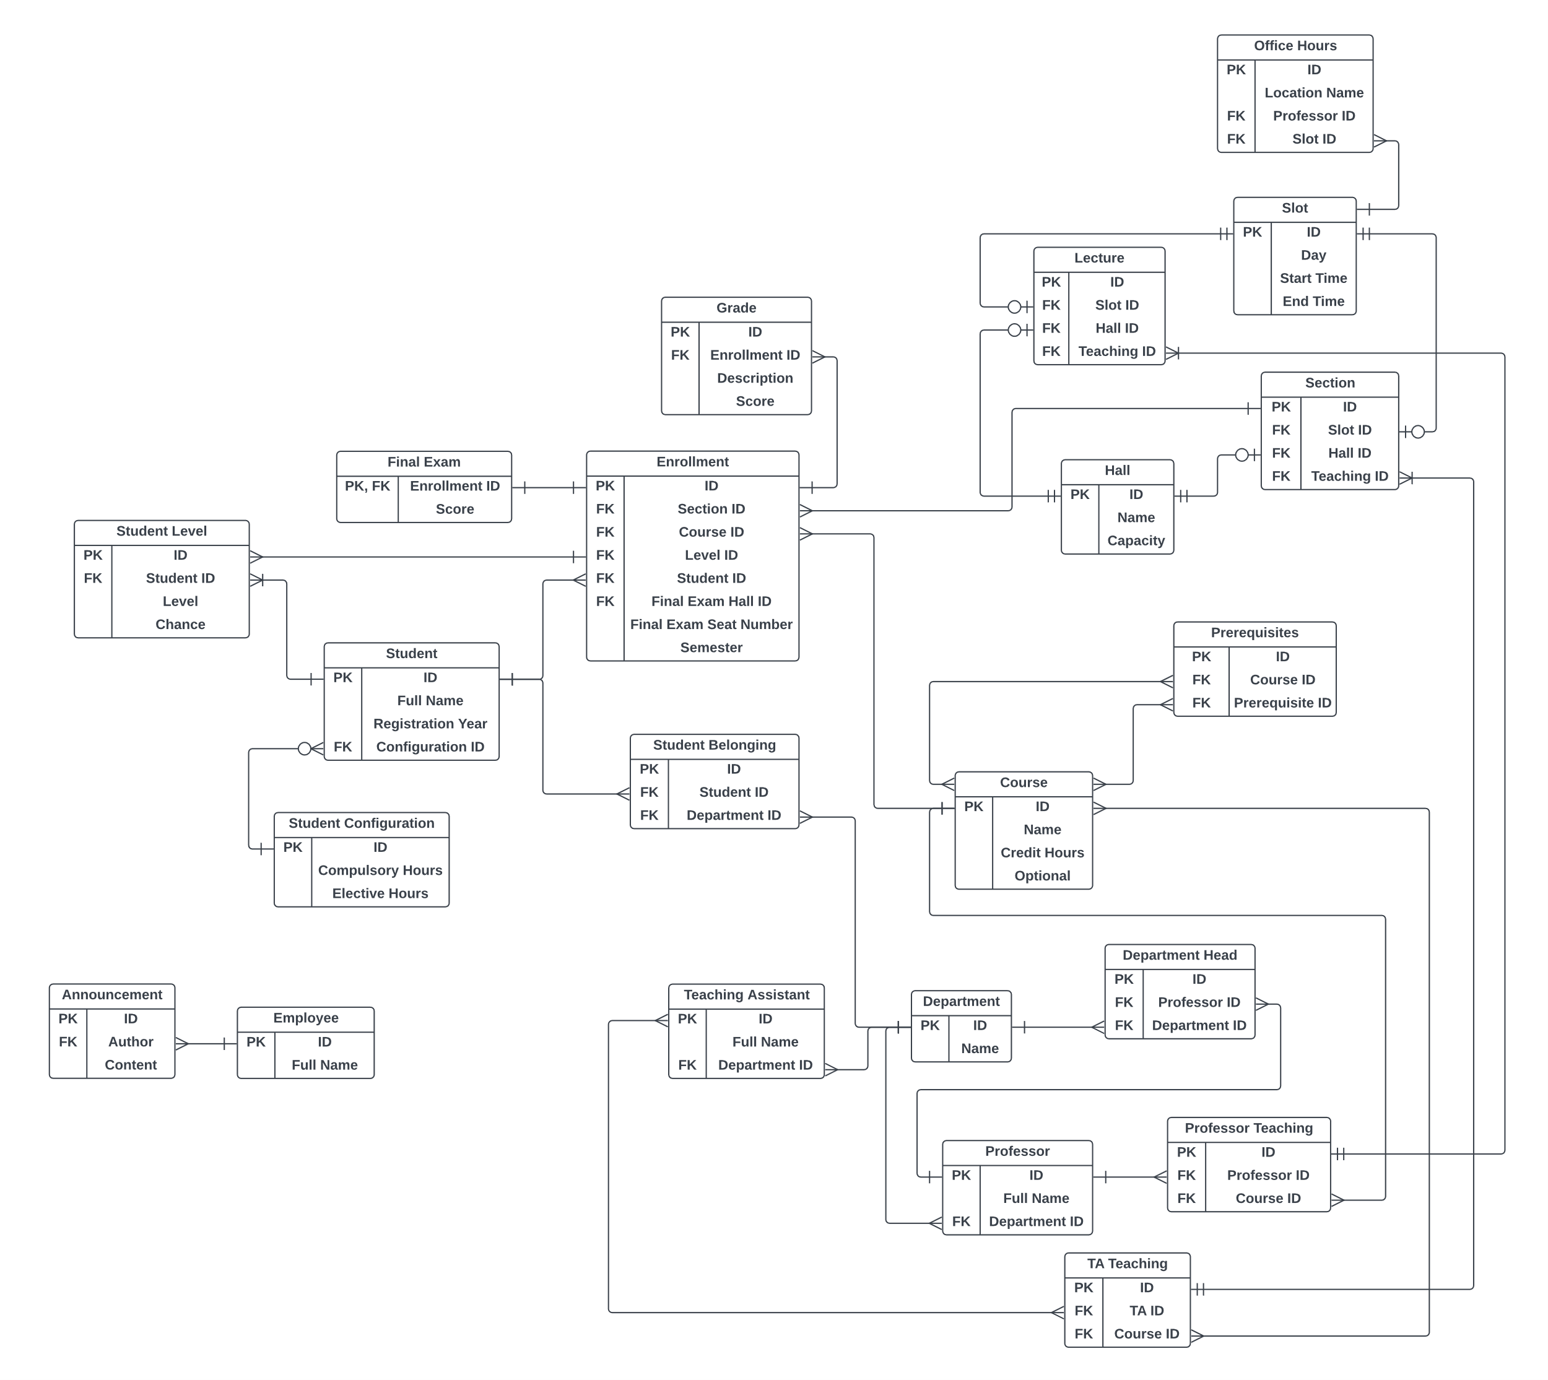
Figure 5. ERD

Component Diagram
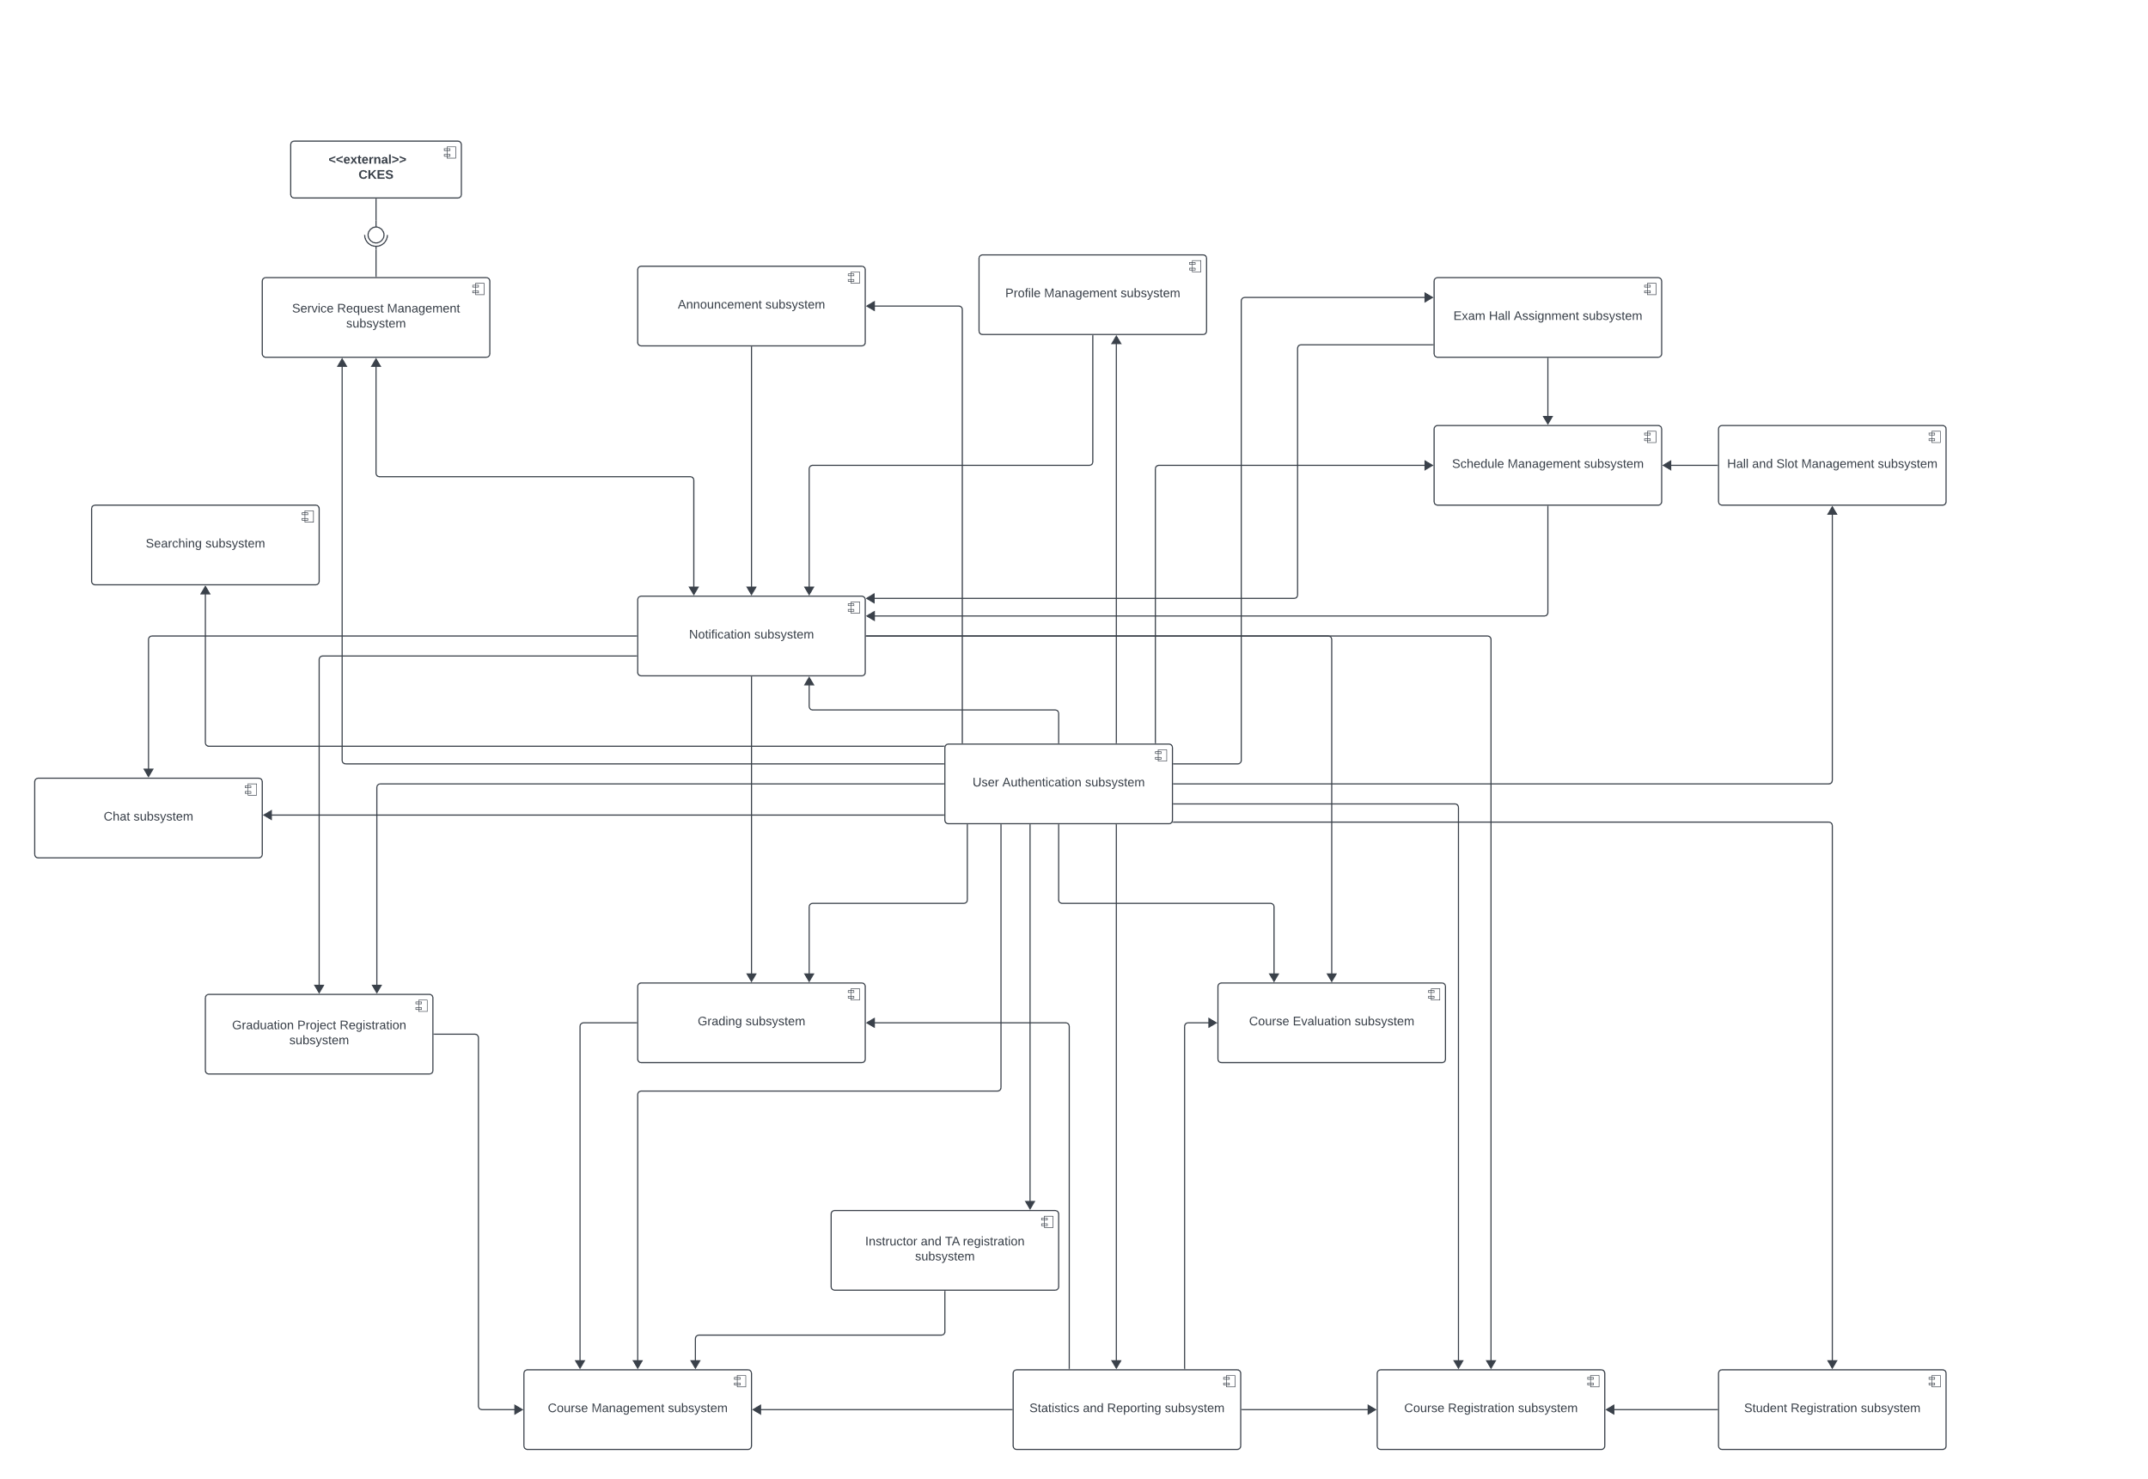
Figure 6. Component Diagram

Sequence Diagram

Register Course (Ecom 2023)

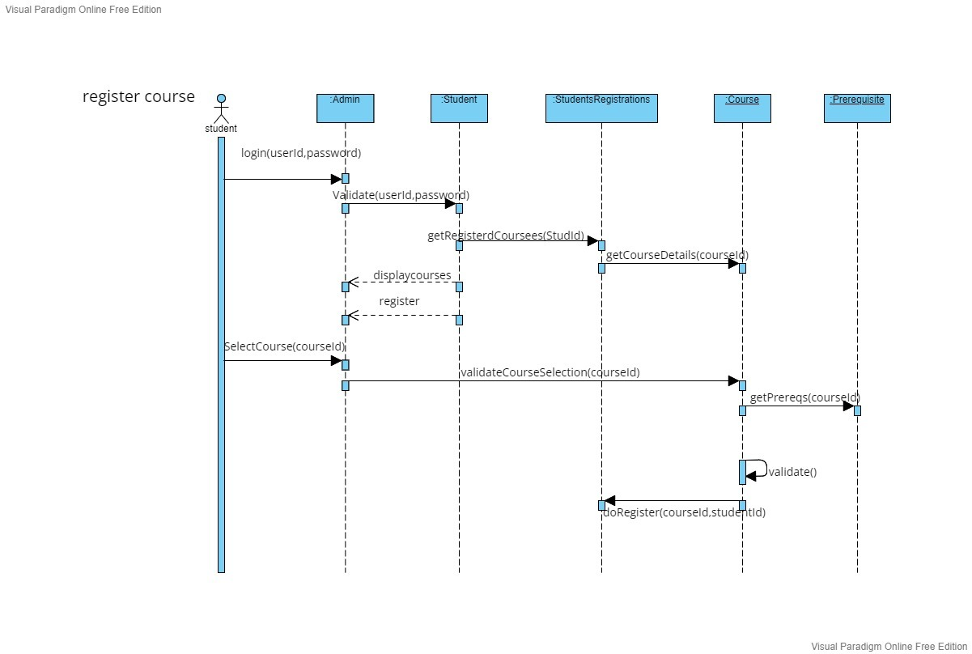
Figure 7. Register Course Sequence Diagram (Ecom 2023)

Internal Chat (Ecom 2023)

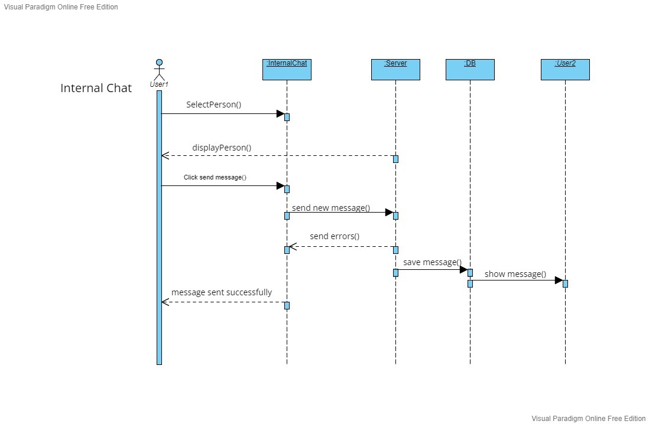
Figure 8. Internal Chat (Ecom 2023)

View Office Hours (Ecom 2023)

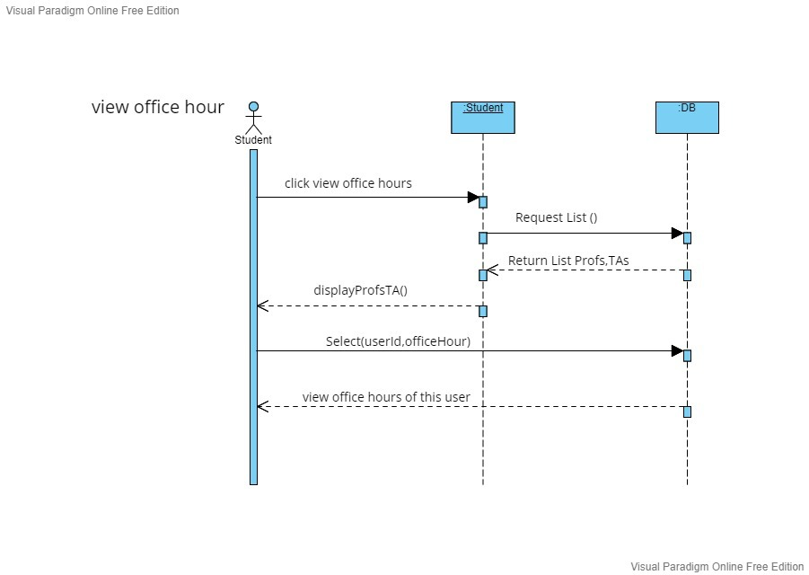
Figure 9. View Office Hours sequence Diagram (Ecom 2023)

View Schedule (Ecom 2023)

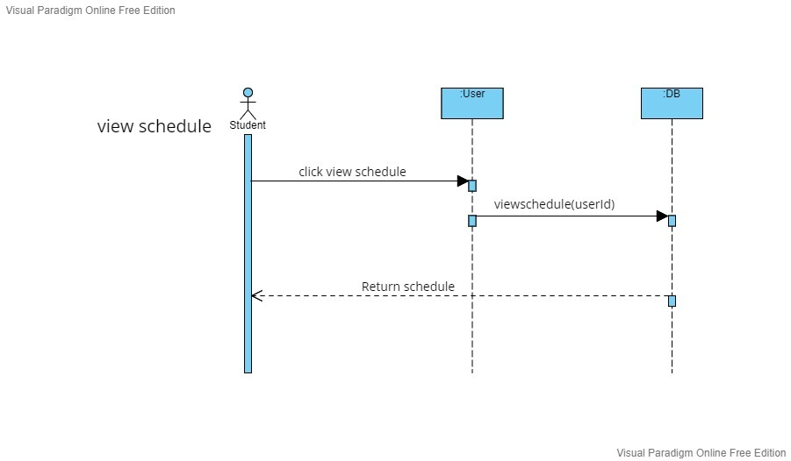
Figure 10. View Schedule Sequence Diagram (Ecom 2023)

Student Registration
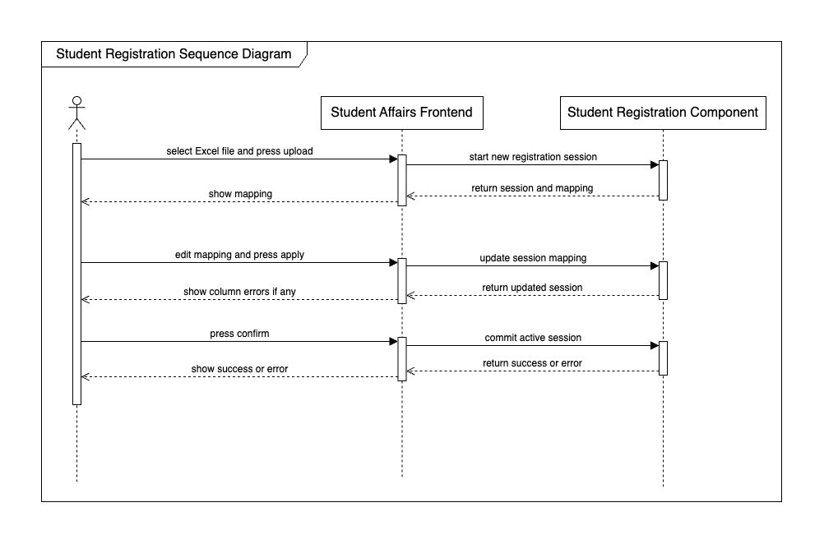
Figure 11. Student Registration Sequence Diagram

BPMN

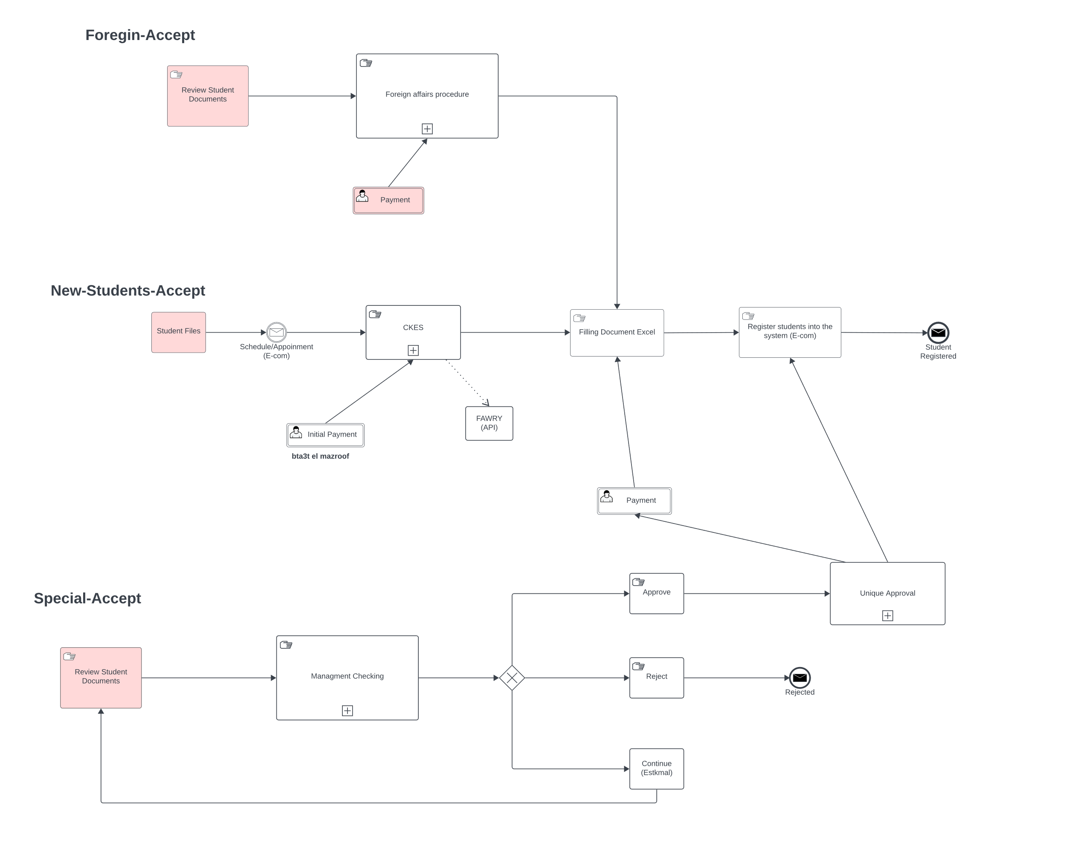
Student Registration
Figure 12. Student Accept

Stop Credential
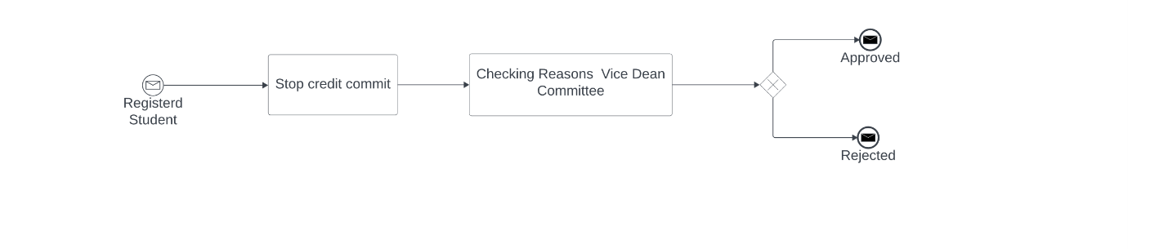

Withdrawal/Incomplete
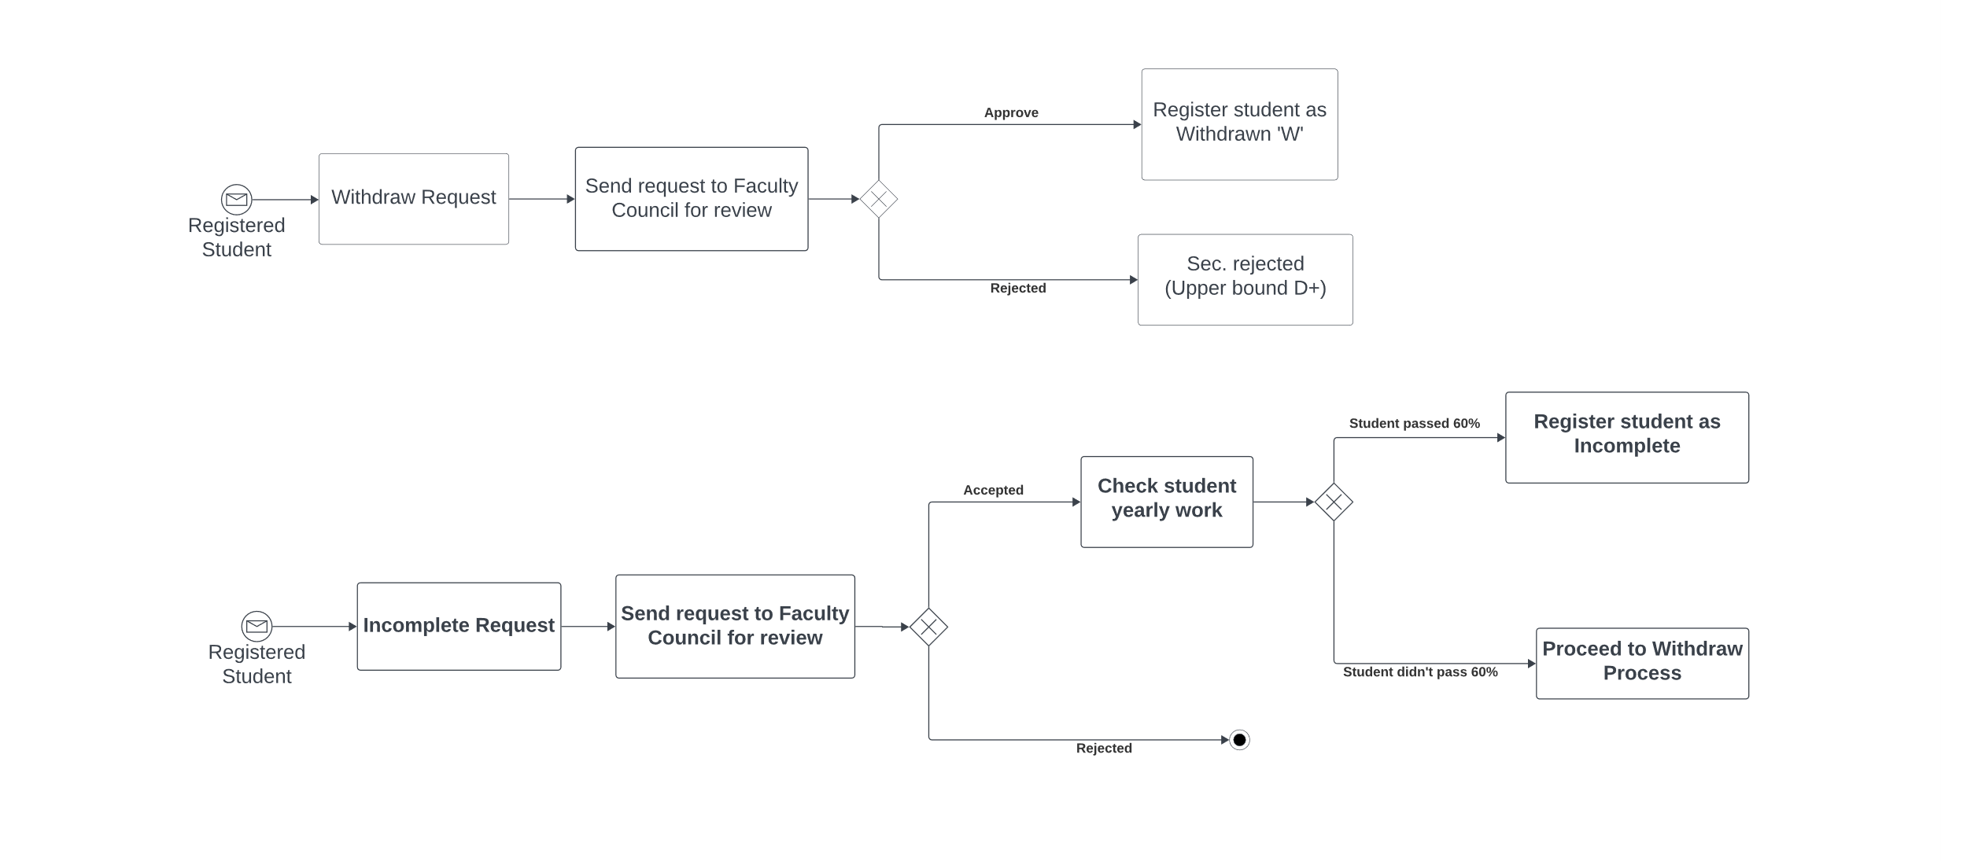

Clearing
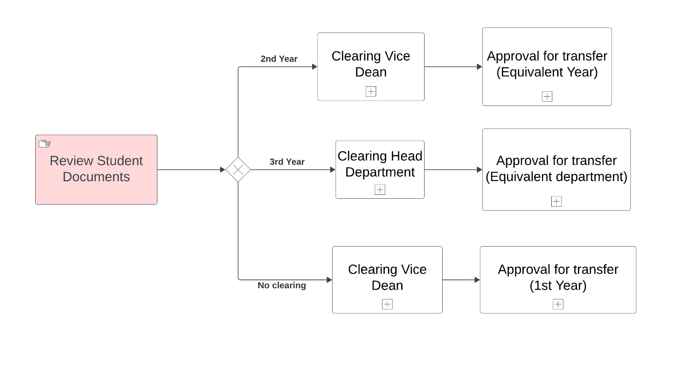

Design & Implementation

Technologies and Tools
Lucid Chart | Web-based diagramming application we used it for making component Diagram, use case diagrams, ERD, sequence diagrams and BPMNs.
Next.js Framework | React-based web applications with server-side rendering and static website generation.
Express Framework | Back-end web application framework for building RESTful APIs with Node.js.
GitHub | Developer platform for creating, storing, managing, and sharing our code.
Visual Studio Code | Source code editor.
Figma | Collaborative web application for interface design.
Hoppscotch.io | Web-based API development suite, for testing APIs.

System Screens
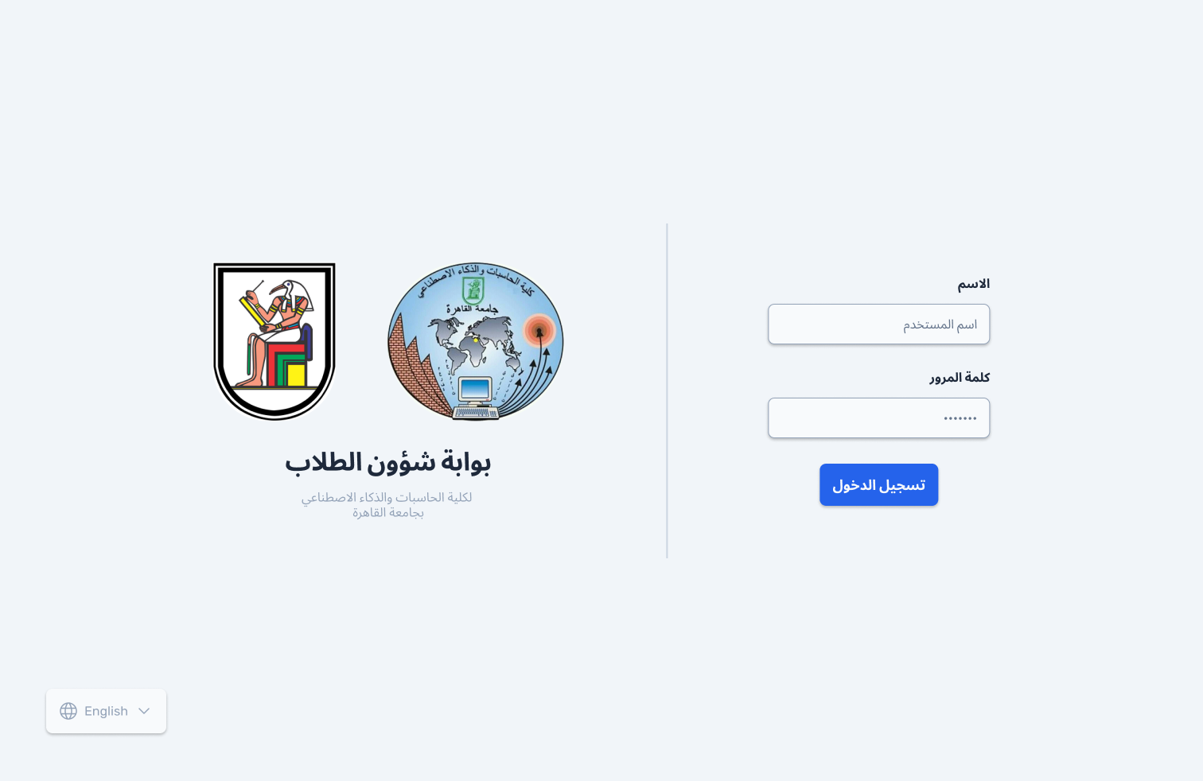
Figure 13. Authentication screen
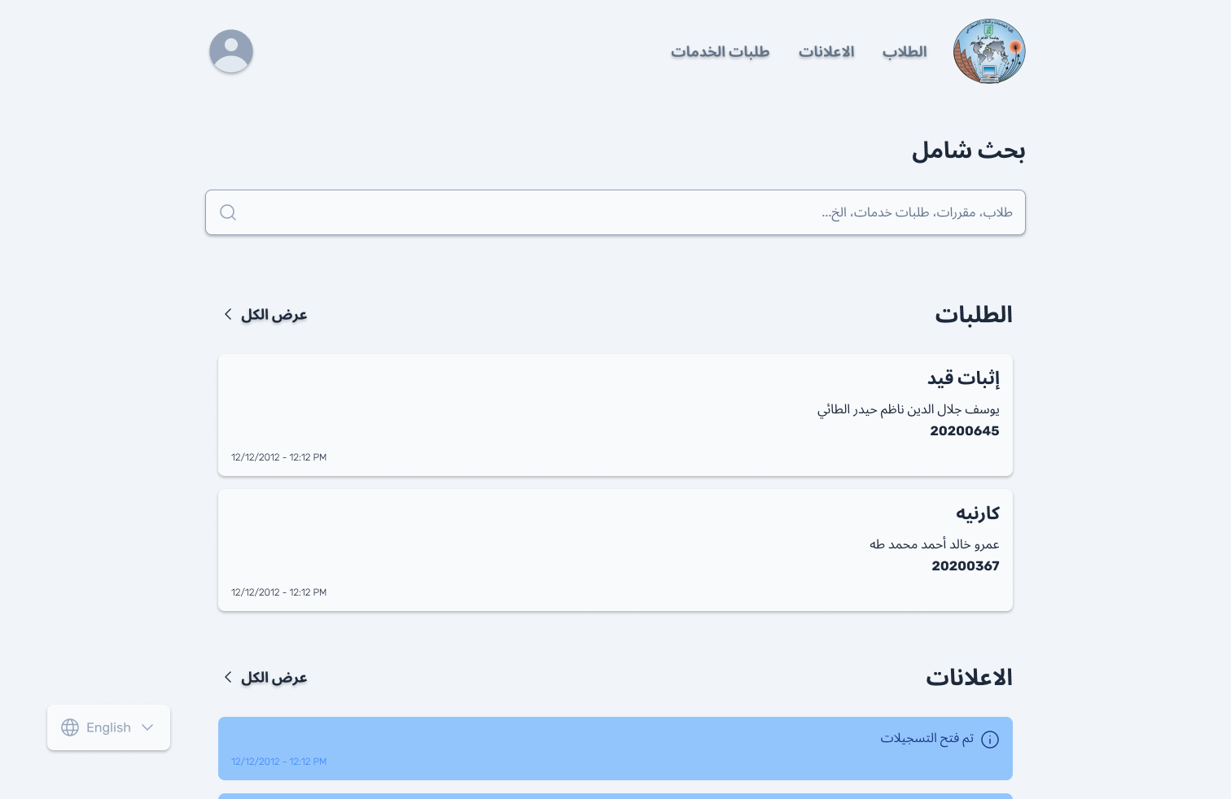
Figure 14. Home page
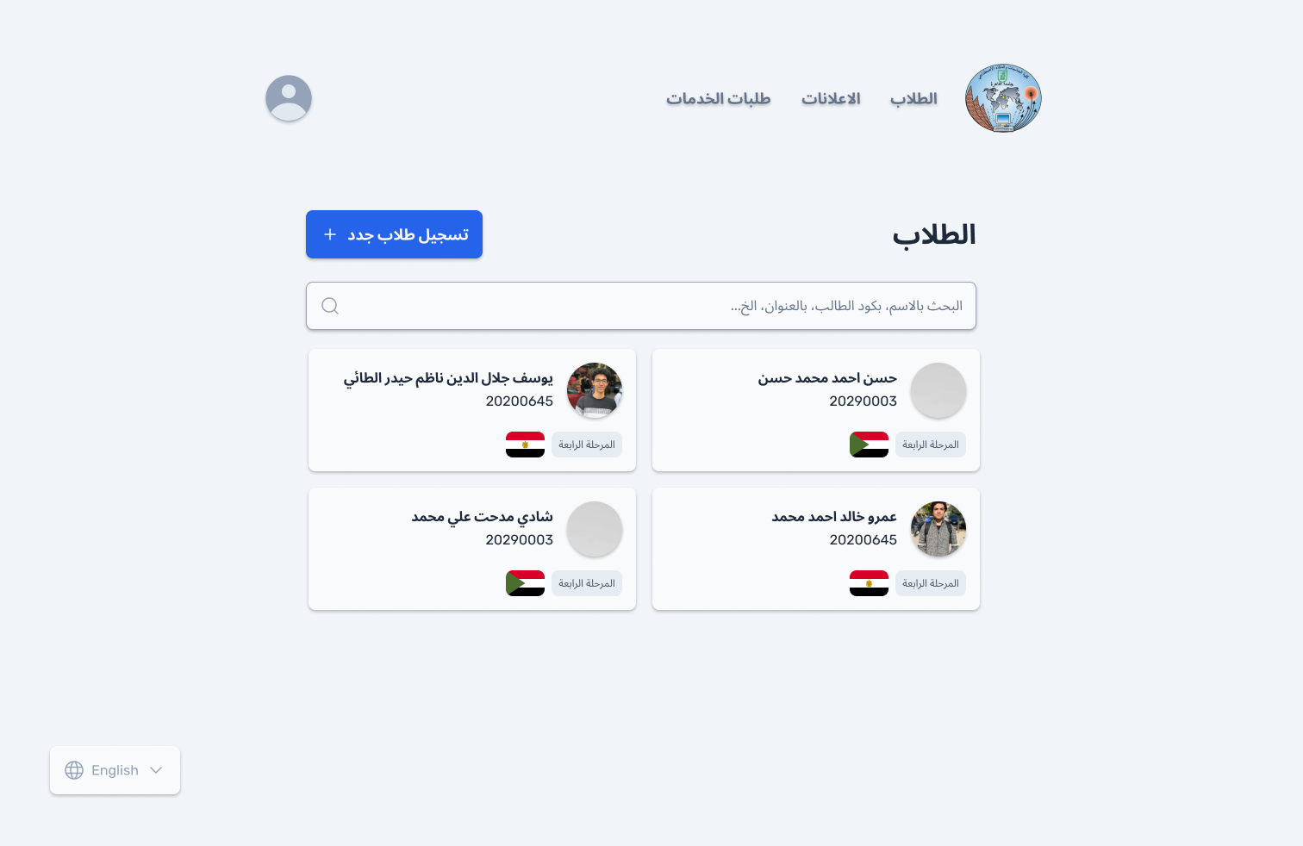
Figure 15. Students
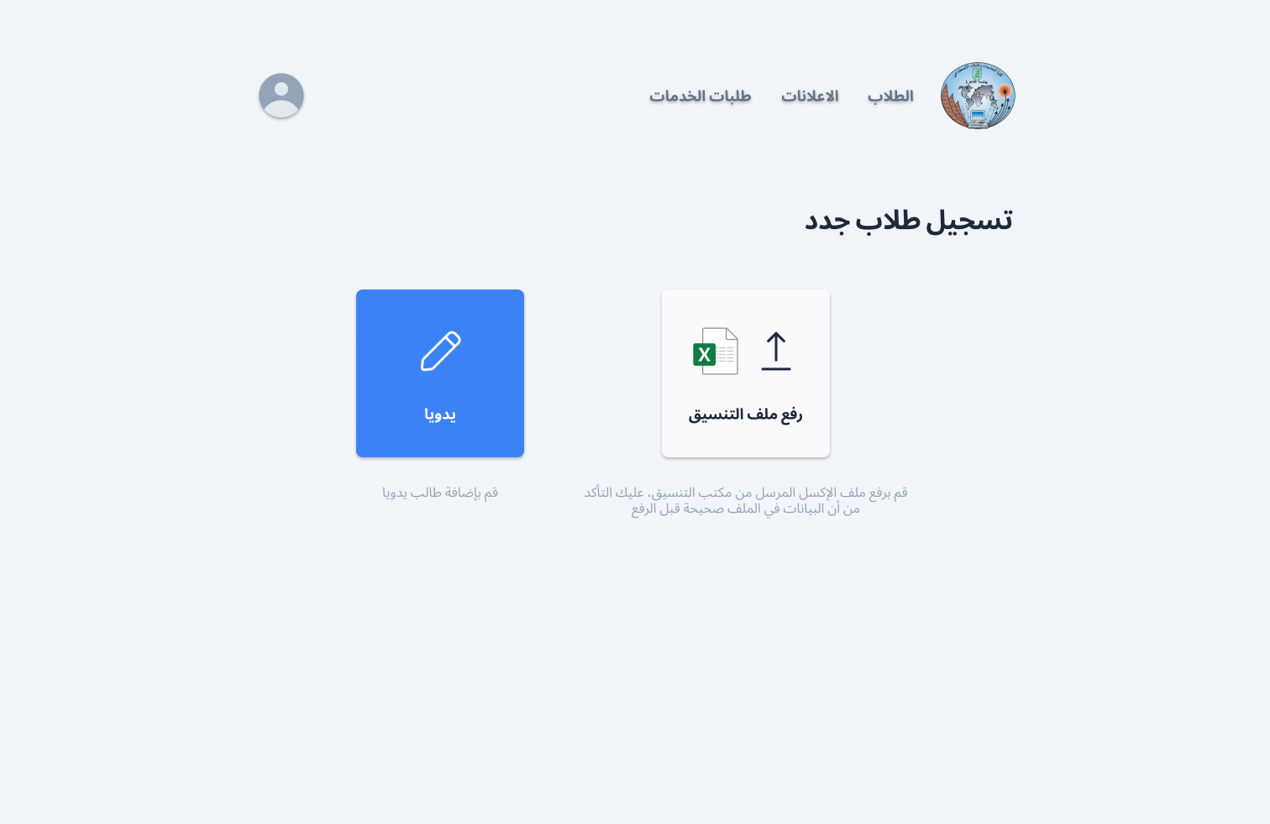
Figure 16. Register New Students.
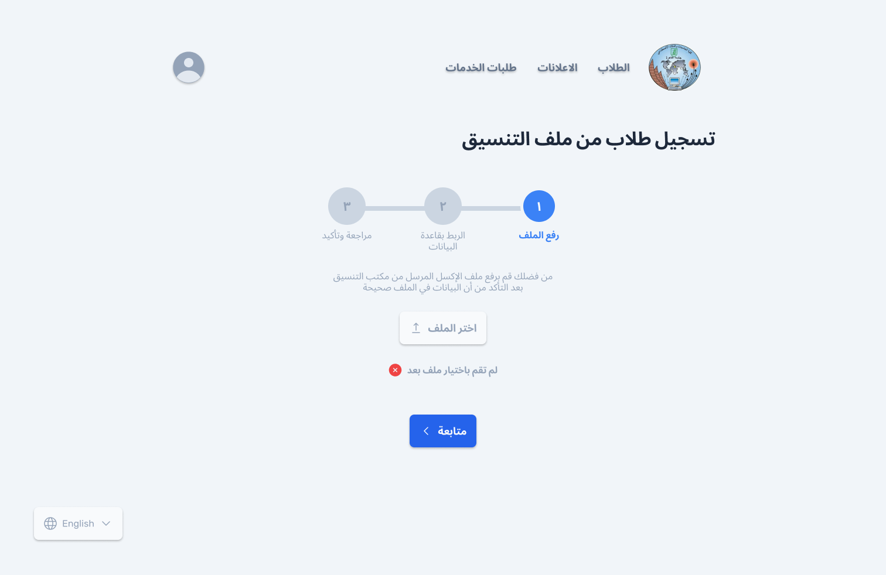
Figure 17. Choose Excel File
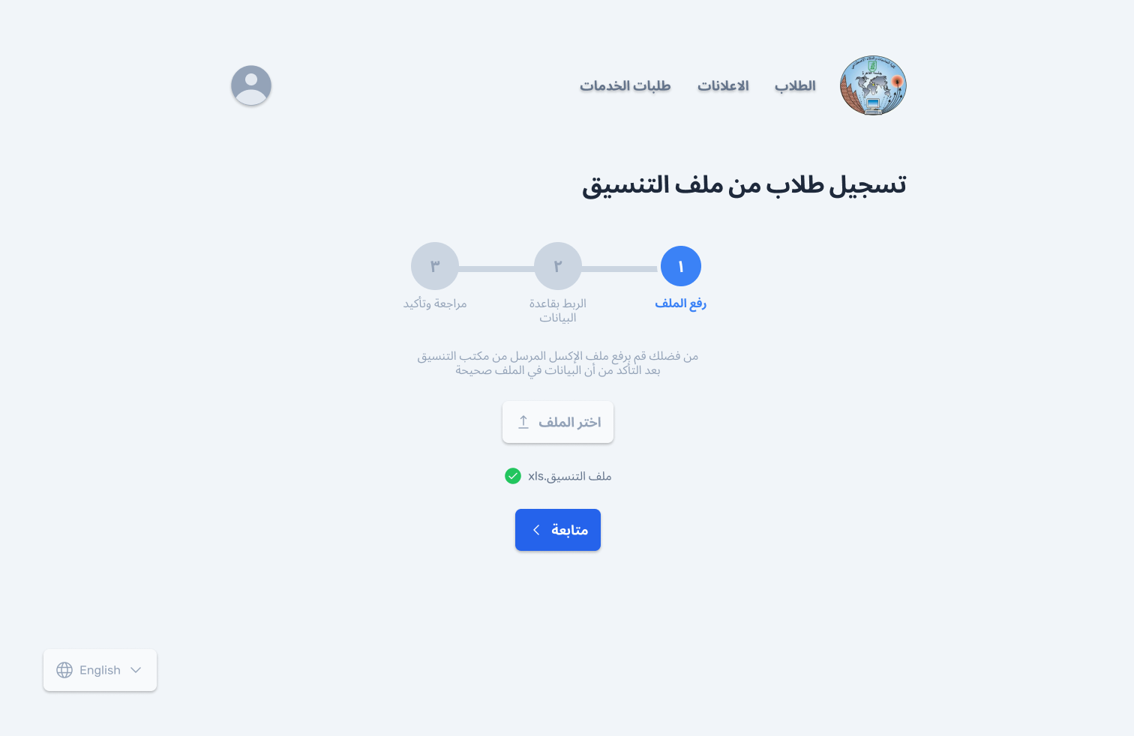
Figure 18. Upload Excel File
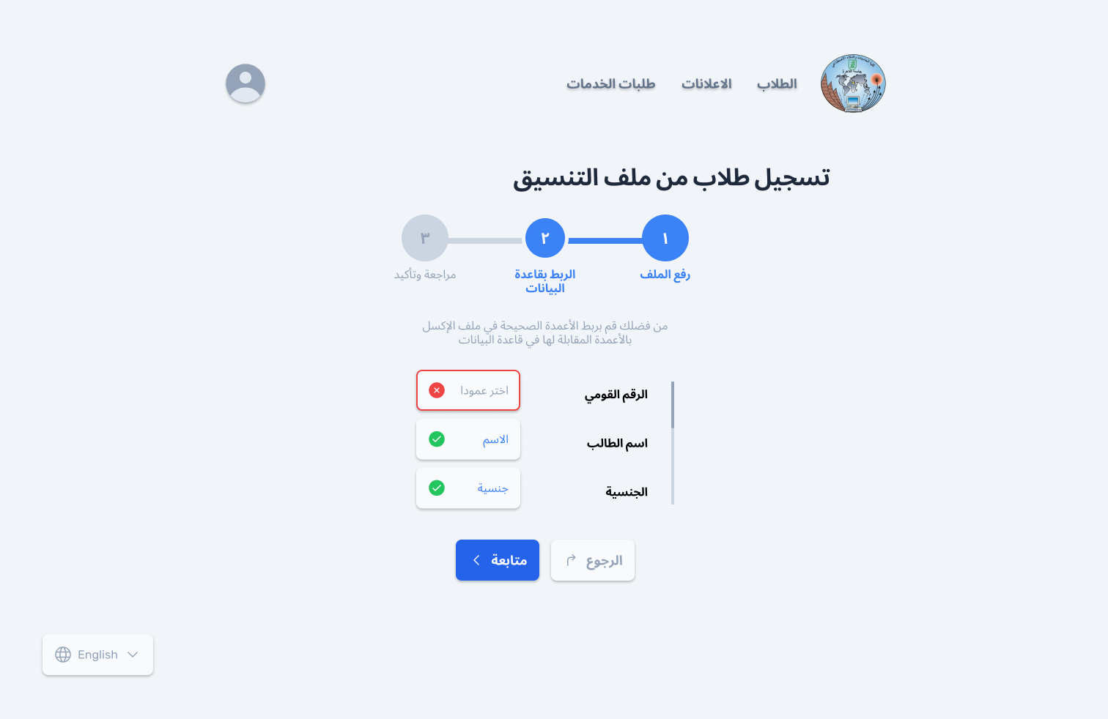
Figure 19. Mapping-1
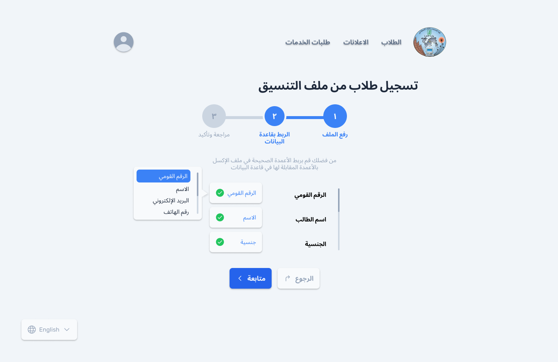
Figure 20. Mapping-2
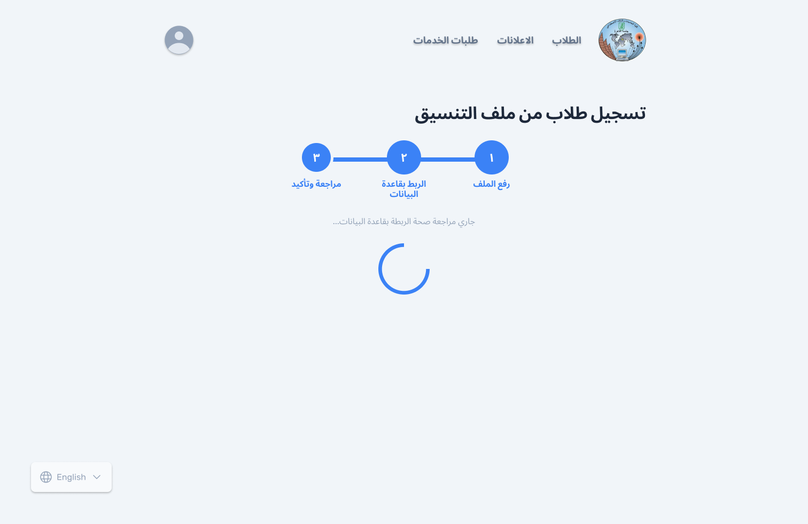
Figure 21. Loading Screen
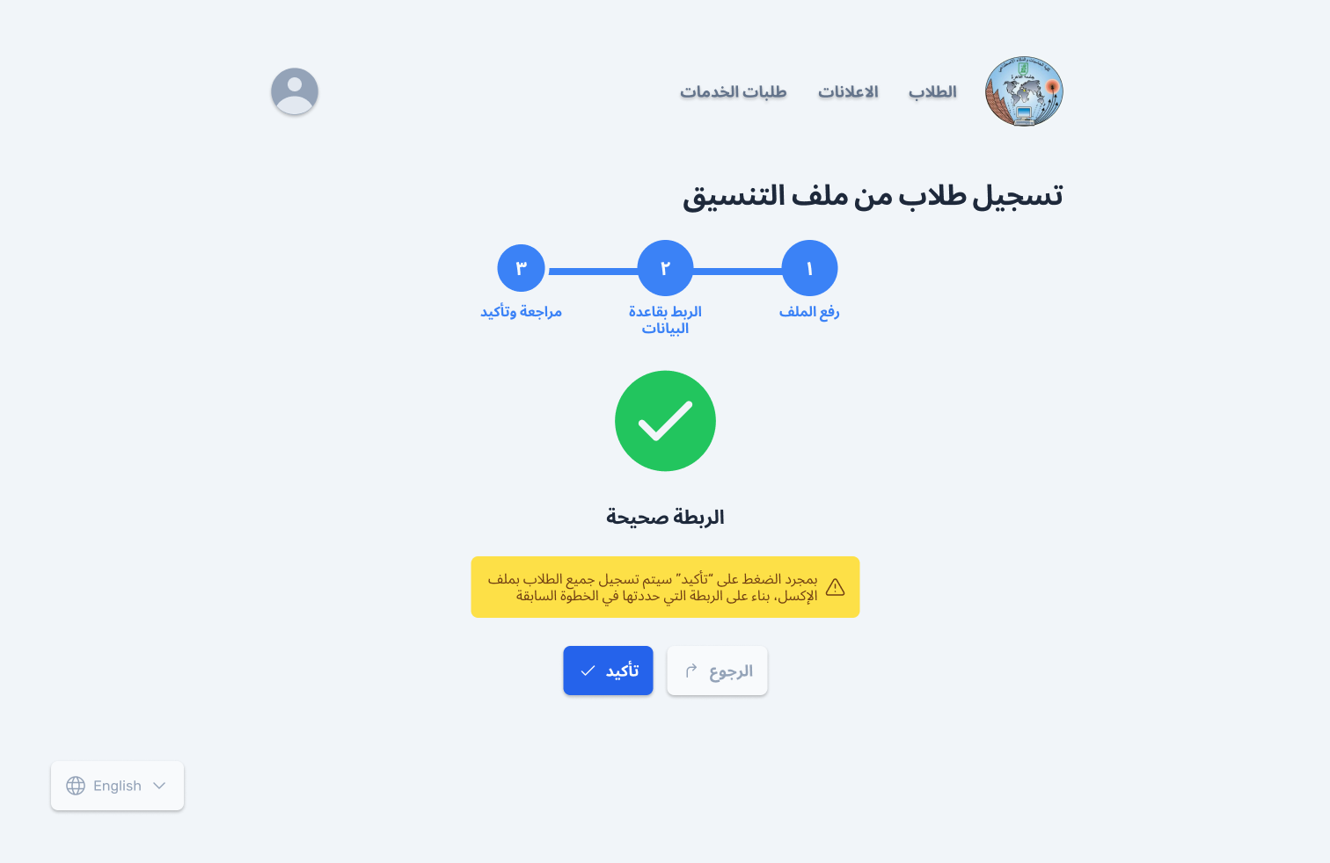
Figure 22. Confirmation

